Name : Pranali Sonawane
Subject : CCNA
Static Routing (Static Configuration of Router)

Lab Practical 2:
- Start by placing 2 routers, 2 switches, and 4 PCs on your workspace. Connect the routers with a crossover cable. Then, connect each switch to its router and the PCs to the switches using straight-through cables. Assign IP addresses and configure static routes.

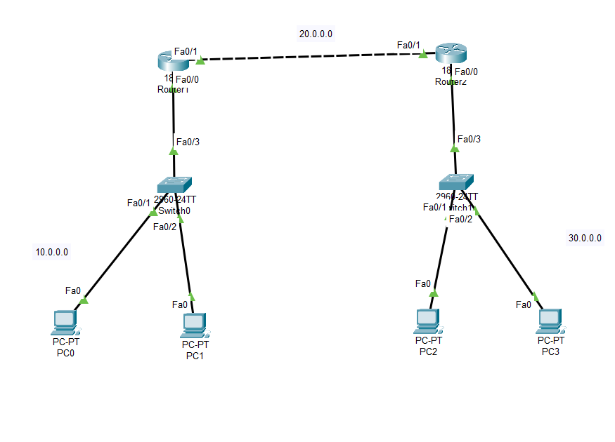
Open Router 0 – CLI prompt then type following commands
Step 1: Configure Router R1
- Open Router 0 and go to the CLI.
- Type the following commands:
Router> enable
Router# configure terminal
Router(config)# hostname R1
R1(config)# interface fastEthernet 0/0
R1(config-if)# ip address 10.0.0.1 255.0.0.0
R1(config-if)# no shutdown
Step 2: Configure PCs connected to R1
- PC0:
  - IPv4 Address: 10.0.0.2
  - Subnet Mask: 255.0.0.0
  - Default Gateway: 10.0.0.1
- PC1:
  - IPv4 Address: 10.0.0.3
  - Subnet Mask: 255.0.0.0
  - Default Gateway: 10.0.0.1
Step 3: Configure the second interface of R1
R1(config-if)# exit
R1(config)# interface fastEthernet 0/1
R1(config-if)# ip address 20.0.0.1 255.0.0.0
R1(config-if)# no shutdown

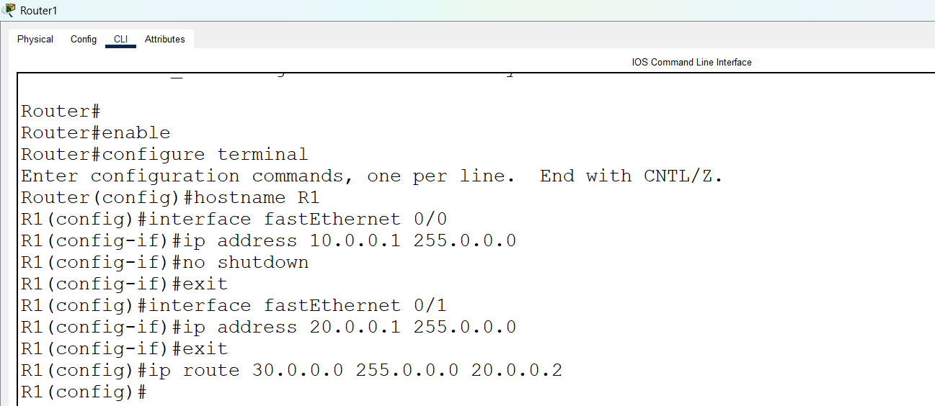
Step 1: Configure Router R2
- Open Router 1 and access the CLI.
- Enter the following commands:
Router> enable
Router# configure terminal
Router(config)# hostname R2
R2(config)# interface fastEthernet 0/0
R2(config-if)# ip address 30.0.0.1 255.0.0.0
R2(config-if)# no shutdown
Step 2: Configure PCs connected to R2
- PC2:
  - IPv4 Address: 30.0.0.2
  - Subnet Mask: 255.0.0.0
  - Default Gateway: 30.0.0.1
- PC3:
  - IPv4 Address: 30.0.0.3
  - Subnet Mask: 255.0.0.0
  - Default Gateway: 30.0.0.1
Step 3: Configure the second interface of R2
R2(config-if)# exit
R2(config)# interface fastEthernet 0/1
R2(config-if)# ip address 20.0.0.2 255.0.0.0
R2(config-if)# no shutdown

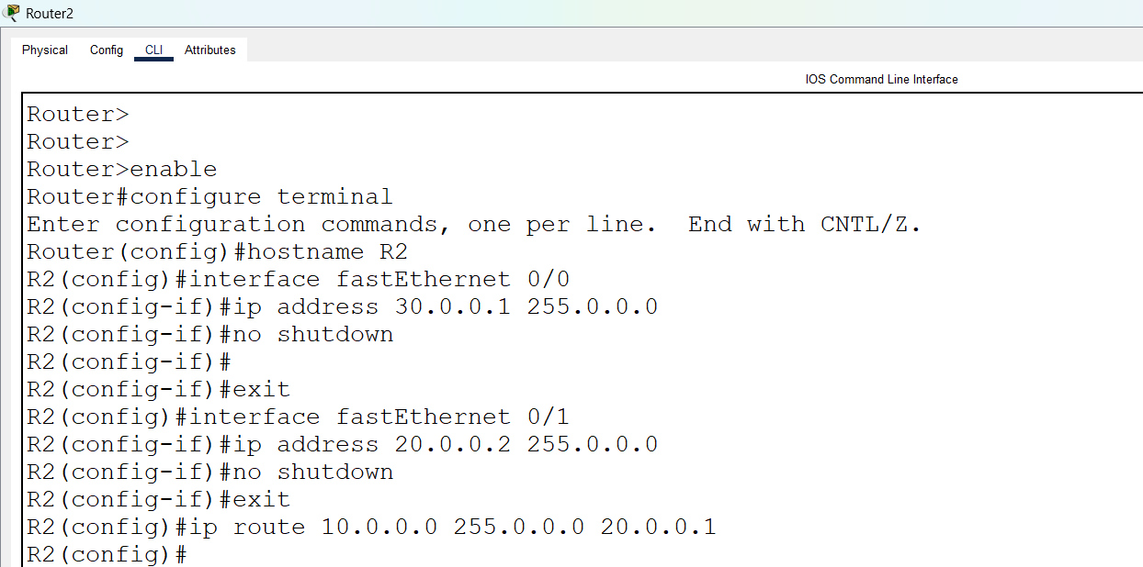
Step 1: Add Static Routes on Routers
- On Router R1 (R1 CLI):
R1(config-if)# exit
R1(config)# ip route 30.0.0.0 255.0.0.0 20.0.0.2
- On Router R2 (R2 CLI):
R2(config-if)# exit
R2(config)# ip route 10.0.0.0 255.0.0.0 20.0.0.1

Step 2: Test Connectivity
- On PC0, open the Command Prompt and type:
> ping 30.0.0.2
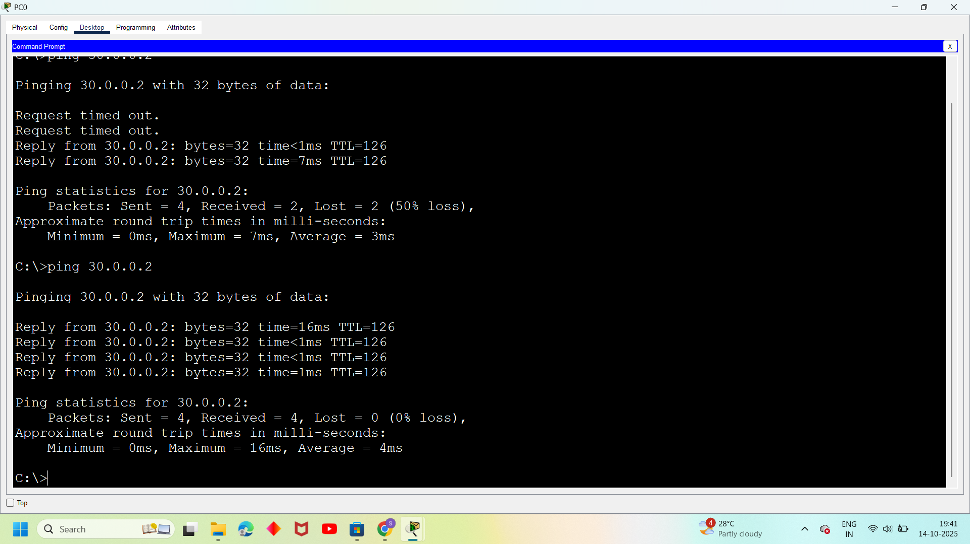
- On PC2, open the Command Prompt and type:
> ping 10.0.0.1

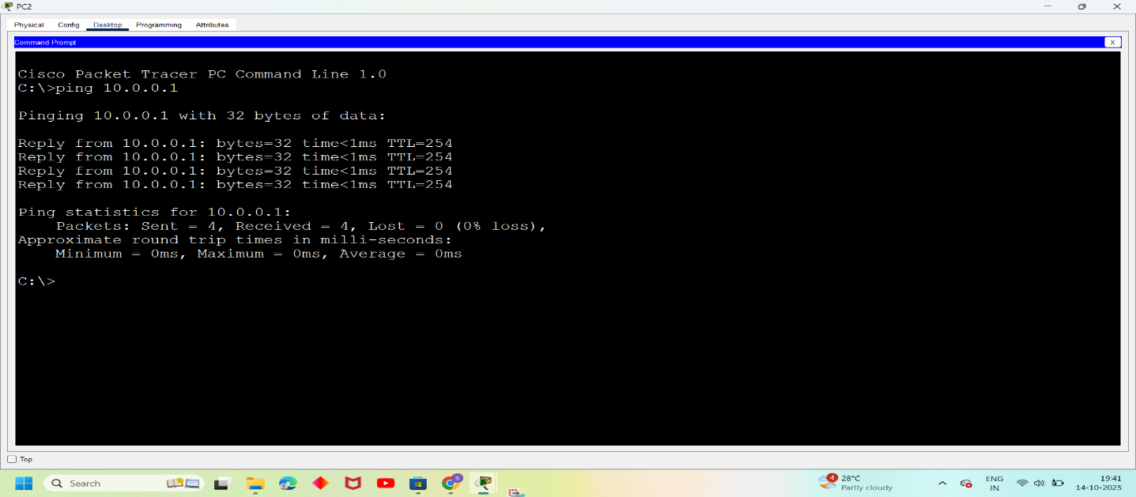
- First Take 3 Routers (Ex: 1841), 3 Switches And 6 Pc’s, Connect Routers Using Crossover Cable , Switches And Pc’s Using Straight Through Cables.
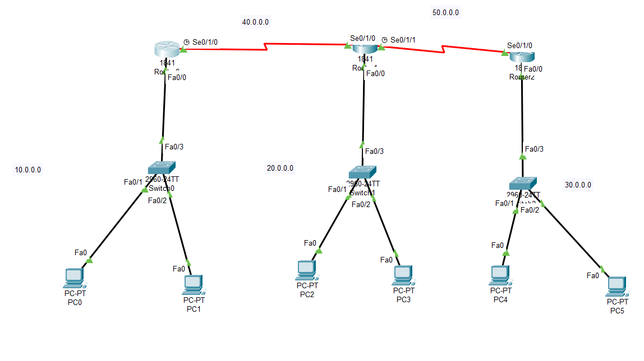

Open Router 0 – CLI prompt then type following commands
Router>enable
Router#configure terminal
Router(config)# interface fastEthernet 0/0
Router(config-if)# ip address 10.0.0.1 255.0.0.0
Router(config-if)#no shutdown
Open pc 0 – desktop—ip configuration – provide ipv4 address (10.0.0.2) – subnet mask (255.0.0.0) – default gateway (10.0.0.1)
Open pc 1 – desktop—ip configuration – provide ipv4 address (10.0.0.3) – subnet mask (255.0.0.0) – default gateway (10.0.0.1)
Open Router 0 – CLI prompt then type following commands
Router(config-if)#exit
Router(config)# interface serial0/1/0
Router(config-if)# ip address 40.0.0.1 255.0.0.0
Router(config-if)# no shutdown

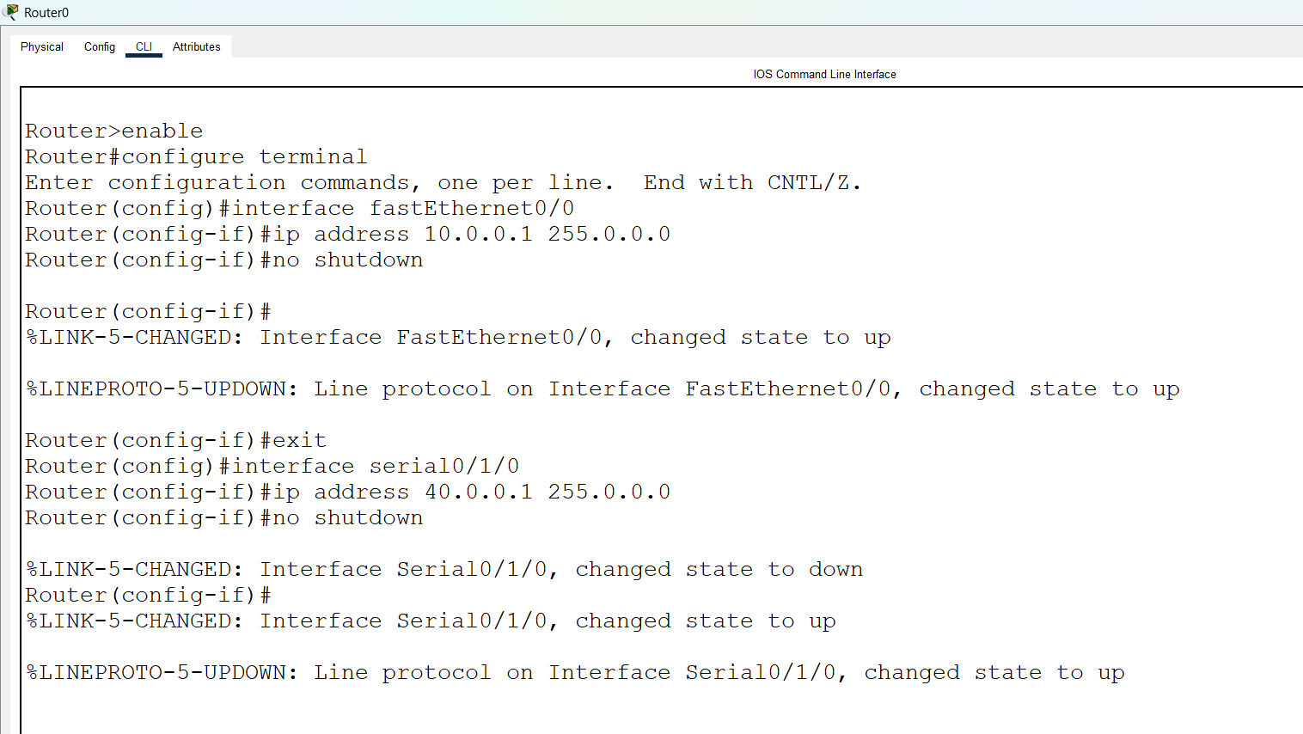
Open Router 1 – CLI prompt then type following commands
Router>enable
Router#configure terminal
Router(config)# interface fastEthernet 0/0
Router(config-if)# ip address 20.0.0.1 255.0.0.0
Router(config-if)#no shutdown

Open pc 2 – desktop—ip configuration – provide ipv4 address (20.0.0.2) – subnet mask (255.0.0.0) – default gateway (20.0.0.1)

Open pc 3 – desktop—ip configuration – provide ipv4 address (20.0.0.3) – subnet mask (255.0.0.0) – default gateway (20.0.0.1)

Open Router 1 – CLI prompt then type following commands
Router(config-if)#exit
Router(config)# interface serial0/1/0
Router(config-if)# ip address 40.0.0.2 255.0.0.0
Router(config-if)# no shutdown

Router(config-if)#exit
Router(config)# interface serial0/1/1
Router(config-if)# ip address 50.0.0.1 255.0.0.0
Router(config-if)# no shutdown

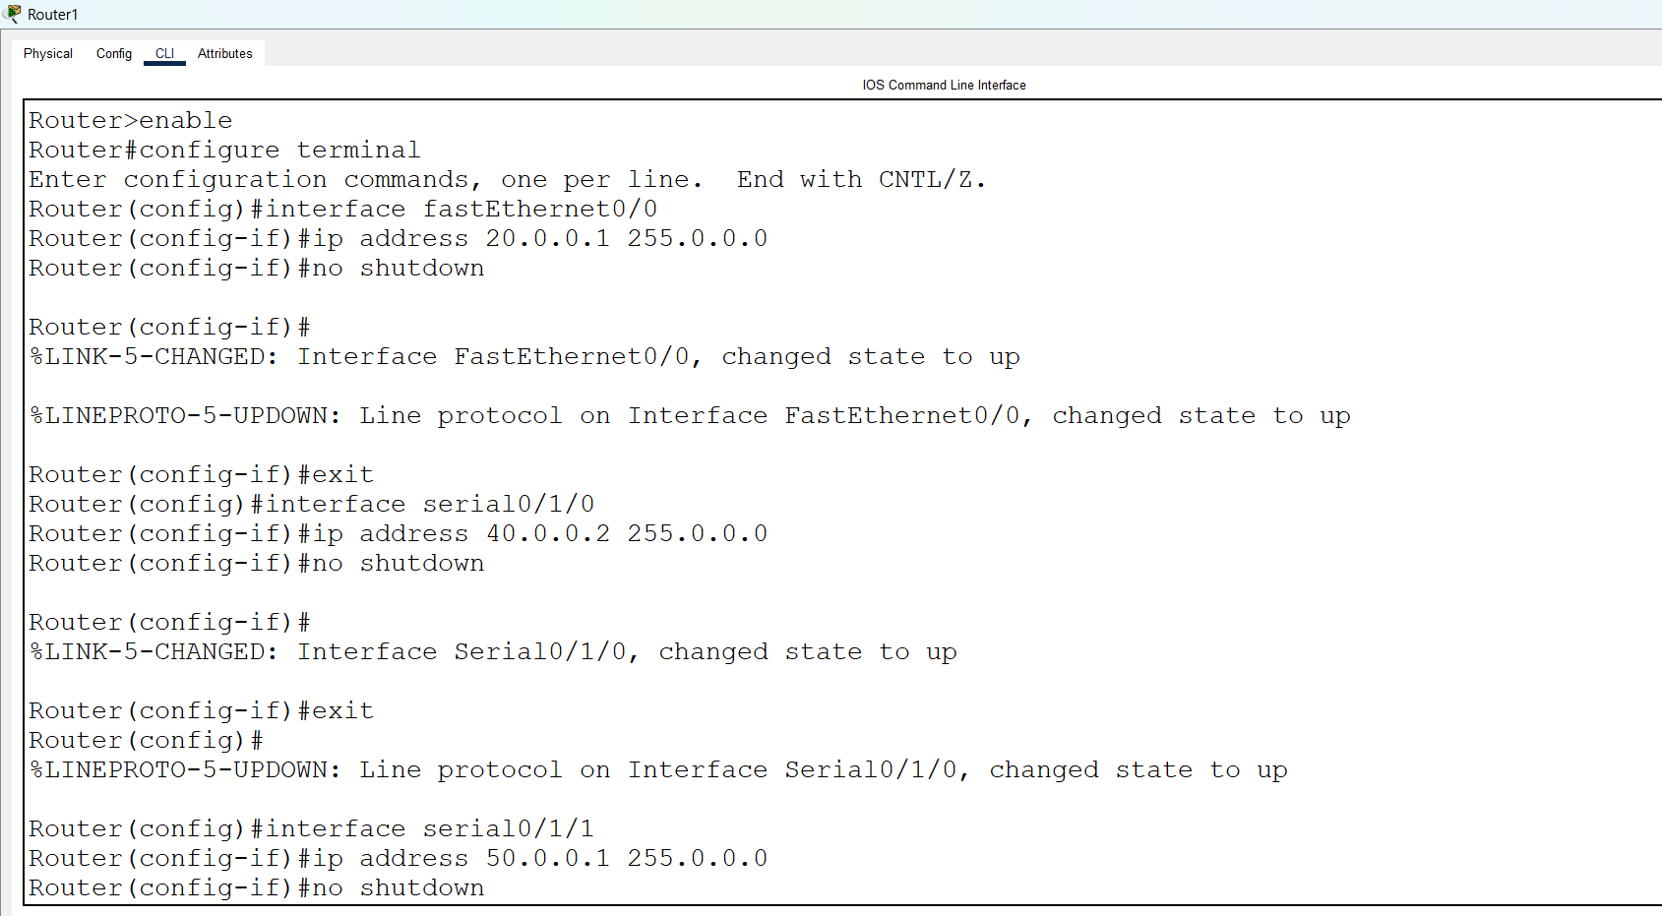

Open Router 2 – CLI prompt then type following commands
Router>enable
Router#configure terminal
Router(config)# interface fastEthernet 0/0
Router(config-if)# ip address 30.0.0.1 255.0.0.0
Router(config-if)#no shutdown

Open pc 4 – desktop—ip configuration – provide ipv4 address (30.0.0.2) – subnet mask (255.0.0.0) – default gateway (30.0.0.1)

Open pc 5 – desktop—ip configuration – provide ipv4 address (30.0.0.3) – subnet mask (255.0.0.0) – default gateway (30.0.0.1)

Open Router 2 – CLI prompt then type following commands
Router(config-if)#exit
Router(config)# interface serial0/1/0
Router(config-if)# ip address 50.0.0.2 255.0.0.0
Router(config-if)# no shutdown
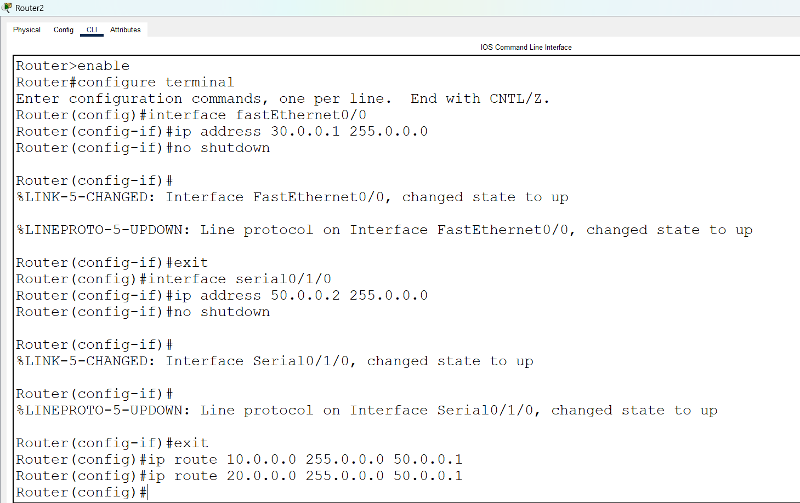
Open Router 0 – CLI prompt then type following command
Router(config-if)#exit
Router(config)#ip route 20.0.0.0 255.0.0.0 40.0.0.2
Router(config)#ip route 30.0.0.0 255.0.0.0 40.0.0.2

Open Router 1 – CLI prompt then type following command

Roter(config-if)#exit
Router(config)#ip route 10.0.0.0 255.0.0.0 40.0.0.1
Router(config)#ip route 30.0.0.0 255.0.0.0 50.0.0.2

Open Router 2 – CLI prompt then type following command
Roter(config-if)#exit
Router(config)#ip route 10.0.0.0 255.0.0.0 50.0.0.1
Router(config)#ip route 20.0.0.0 255.0.0.0 50.0.0.1

Open pc 0 – cmd prompt – type command
>ping 30.0.0.2
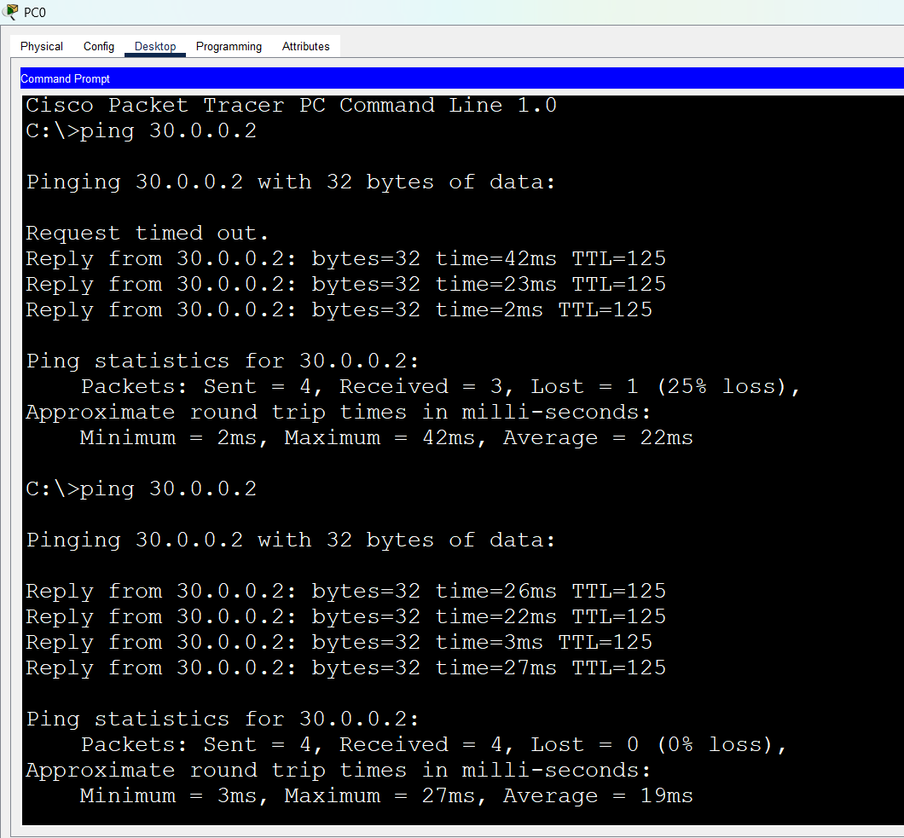
Open pc 2 – cmd prompt – type command
>ping 10.0.0.2
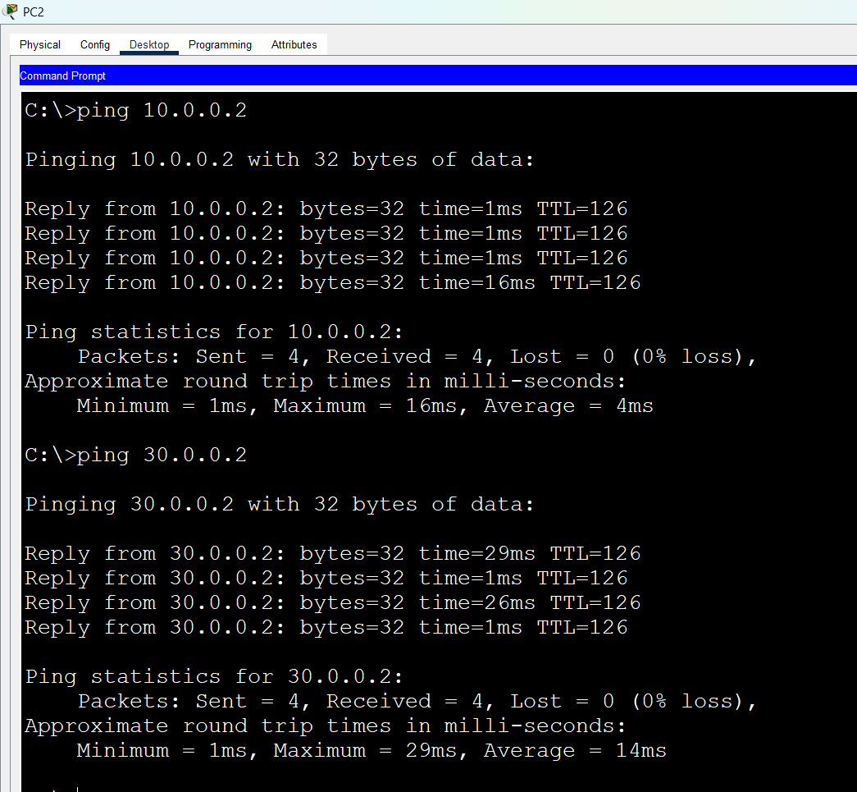
Open pc 4 – cmd prompt – type command
>ping 20.0.0.2
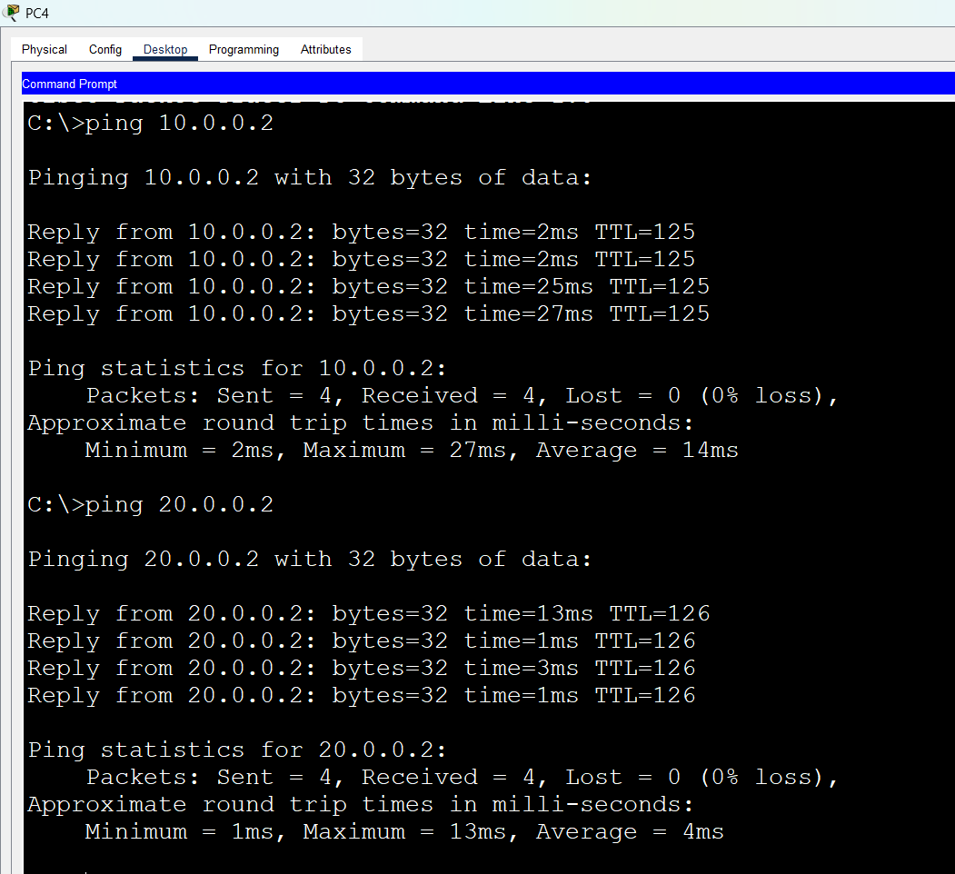
- First Take 4 Routers (Ex: 1841), 4 Switches And Pc’s, Connect Routers Using Crossover Cable , Switches And Pc’s Using Straight Through Cables.

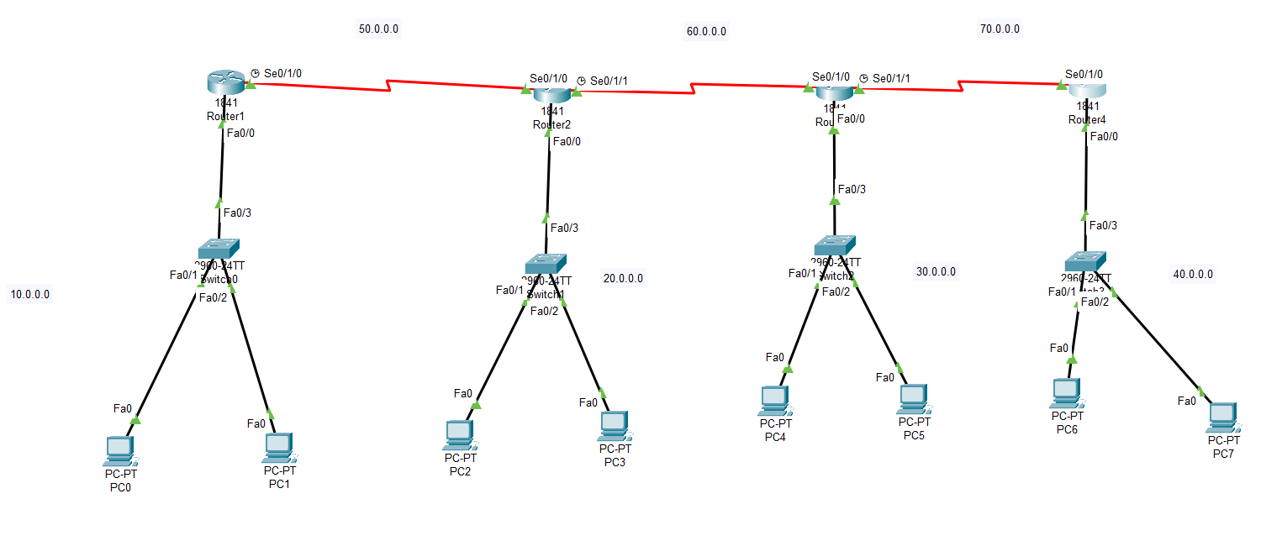
Open Router 1 – CLI prompt then type following commands
Router>enable
Router#configure terminal
Router(config)# interface fastEthernet 0/0
Router(config-if)# ip address 10.0.0.1 255.0.0.0
Router(config-if)#no shutdown
Open pc 0 – desktop—ip configuration – provide ipv4 address (10.0.0.2) – subnet mask (255.0.0.0) – default gateway (10.0.0.1)

Open pc 1 – desktop—ip configuration – provide ipv4 address (10.0.0.3) – subnet mask (255.0.0.0) – default gateway (10.0.0.1)
Open Router 1 – CLI prompt then type following commands

Router(config-if)#exit
Router(config)# interface serial0/1/0
Router(config-if)# ip address 50.0.0.1 255.0.0.0
Router(config-if)# no shutdown

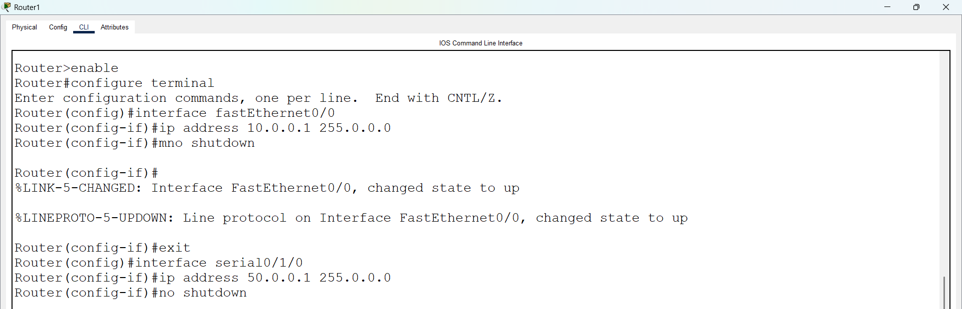

Open Router 2 – CLI prompt then type following commands
Router>enable
Router#configure terminal
Router(config)# interface fastEthernet 0/0
Router(config-if)# ip address 20.0.0.1 255.0.0.0
Router(config-if)#no shutdown

Open pc 2 – desktop—ip configuration – provide ipv4 address (20.0.0.2) – subnet mask (255.0.0.0) – default gateway (20.0.0.1)

Open pc 3 – desktop—ip configuration – provide ipv4 address (20.0.0.3) – subnet mask (255.0.0.0) – default gateway (20.0.0.1)

Open Router 2 – CLI prompt then type following commands
Router(config-if)#exit
Router(config)# interface serial0/1/0
Router(config-if)# ip address 50.0.0.2 255.0.0.0
Router(config-if)# no shutdown

Router(config-if)#exit
Router(config)# interface serial0/1/1
Router(config-if)# ip address 60.0.0.1 255.0.0.0
Router(config-if)# no shutdown

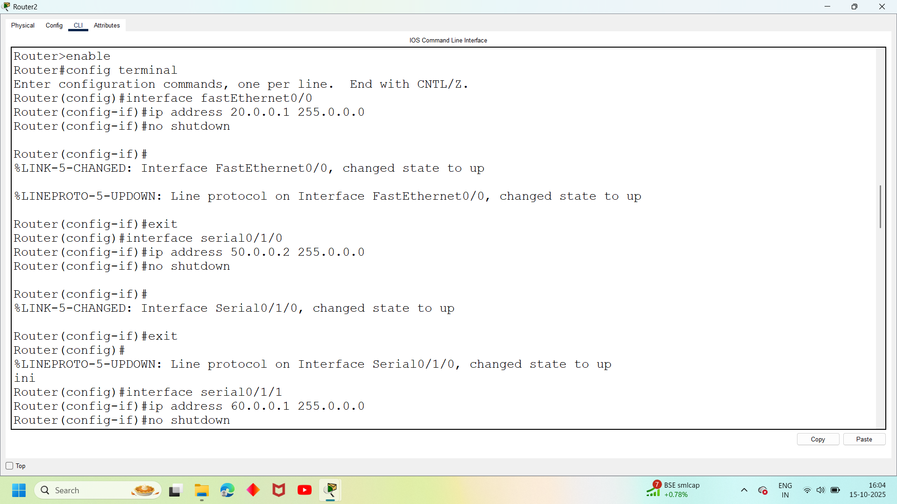

Open Router 3 – CLI prompt then type following commands
Router>enable
Router#configure terminal
Router(config)# interface fastEthernet 0/0
Router(config-if)# ip address 30.0.0.1 255.0.0.0
Router(config-if)#no shutdown

Open pc 4 – desktop—ip configuration – provide ipv4 address (30.0.0.2) – subnet mask (255.0.0.0) – default gateway (30.0.0.1)

Open pc 5 – desktop—ip configuration – provide ipv4 address (30.0.0.3) – subnet mask (255.0.0.0) – default gateway (30.0.0.1)

Open Router 3 – CLI prompt then type following commands
Router(config-if)#exit
Router(config)# interface serial0/1/0
Router(config-if)# ip address 60.0.0.2 255.0.0.0
Router(config-if)# no shutdown

Router(config-if)#exit
Router(config)# interface serial0/1/1
Router(config-if)# ip address 70.0.0.1 255.0.0.0
Router(config-if)# no shutdown

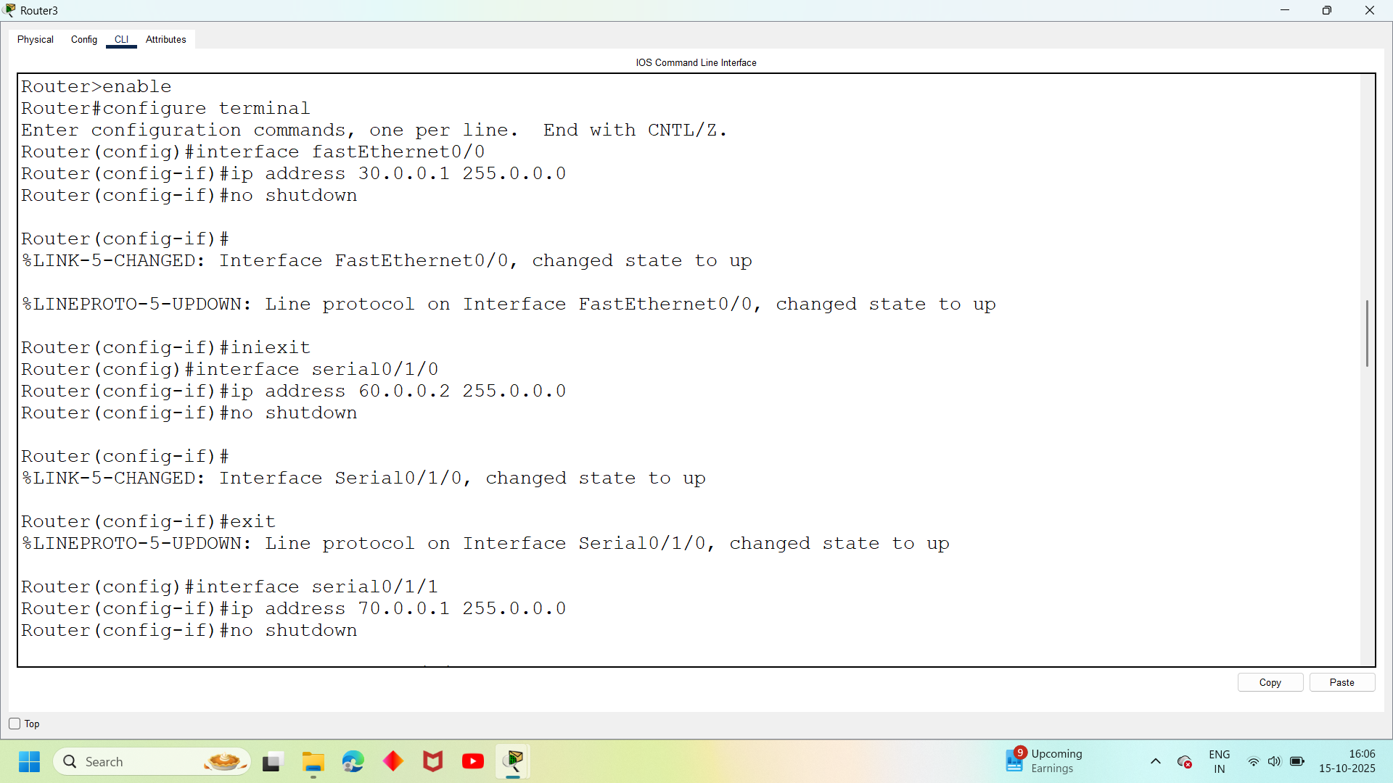
Open Router 4 – CLI prompt then type following commands
Router>enable
Router#configure terminal
Router(config)# interface fastEthernet 0/0
Router(config-if)# ip address 40.0.0.1 255.0.0.0
Router(config-if)#no shutdown

Open pc 6 – desktop—ip configuration – provide ipv4 address (40.0.0.2) – subnet mask (255.0.0.0) – default gateway (40.0.0.1)

Open pc 7 – desktop—ip configuration – provide ipv4 address (40.0.0.3) – subnet mask (255.0.0.0) – default gateway (40.0.0.1)

Open Router 4 – CLI prompt then type following commands
Router(config-if)#exit
Router(config)# interface serial0/1/0
Router(config-if)# ip address 70.0.0.2 255.0.0.0
Router(config-if)# no shutdown

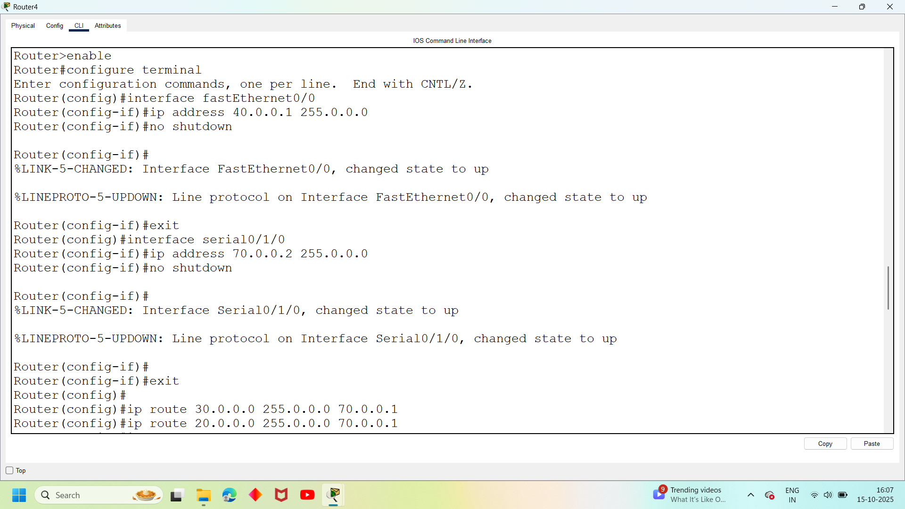

Open Router 1 – CLI prompt then type following command
Router(config-if)#exit
Router(config)#ip route 20.0.0.0 255.0.0.0 50.0.0.2
Router(config)#ip route 30.0.0.0 255.0.0.0 50.0.0.2
Router(config)#ip route 40.0.0.0 255.0.0.0 50.0.0.2
Router(config)#ip route 60.0.0.0 255.0.0.0 50.0.0.2
Router(config)#ip route 70.0.0.0 255.0.0.0 50.0.0.2

Open Router 2 – CLI prompt then type following command

Router(config-if)#exit
Router(config)#ip route 10.0.0.0 255.0.0.0 50.0.0.1
Router(config)#ip route 30.0.0.0 255.0.0.0 60.0.0.2
Router(config)#ip route 70.0.0.0 255.0.0.0 60.0.0.2
Router(config)#ip route 40.0.0.0 255.0.0.0 60.0.0.2

Open Router 3 – CLI prompt then type following command

Router(config-if)#exit
Router(config)#ip route 10.0.0.0 255.0.0.0 60.0.0.1
Router(config)#ip route 20.0.0.0 255.0.0.0 60.0.0.1
Router(config)#ip route 40.0.0.0 255.0.0.0 70.0.0.2
Router(config)#ip route 50.0.0.0 255.0.0.0 60.0.0.1

Open Router 4 – CLI prompt then type following command

Router(config-if)#exit
Router(config)#ip route 10.0.0.0 255.0.0.0 70.0.0.1
Router(config)#ip route 20.0.0.0 255.0.0.0 70.0.0.1
Router(config)#ip route 30.0.0.0 255.0.0.0 70.0.0.1
Router(config)#ip route 50.0.0.0 255.0.0.0 70.0.0.1
Router(config)#ip route 60.0.0.0 255.0.0.0 70.0.0.1

Open pc 0 – cmd prompt – type command
>ping 20.0.0.2
We will get Reply back (acknowledgement ) from pc’s
This Is How We Have Done Static Routing.

